# Youtube:

Youtube is the main platform of videos in the current internet. It allows the user to play, share and upload videos of any topic, always respecting the legal standards, and leave his feedback in form of comments or likes/dislikes in the videos.

Youtube also allows the publisher to stream live videos, allowing the user consume content which is being published by the channel at the moment. Users also may subscribe to their favourite channels and be updated about their content.

## Nielsen’s Heuristics Analysis:

According to Jakob Nielsen, a website must follow ten patterns or laws to provide the consumer a good user experience. We are going to analyse Youtube according to these patterns:

1. Visibility of System Status

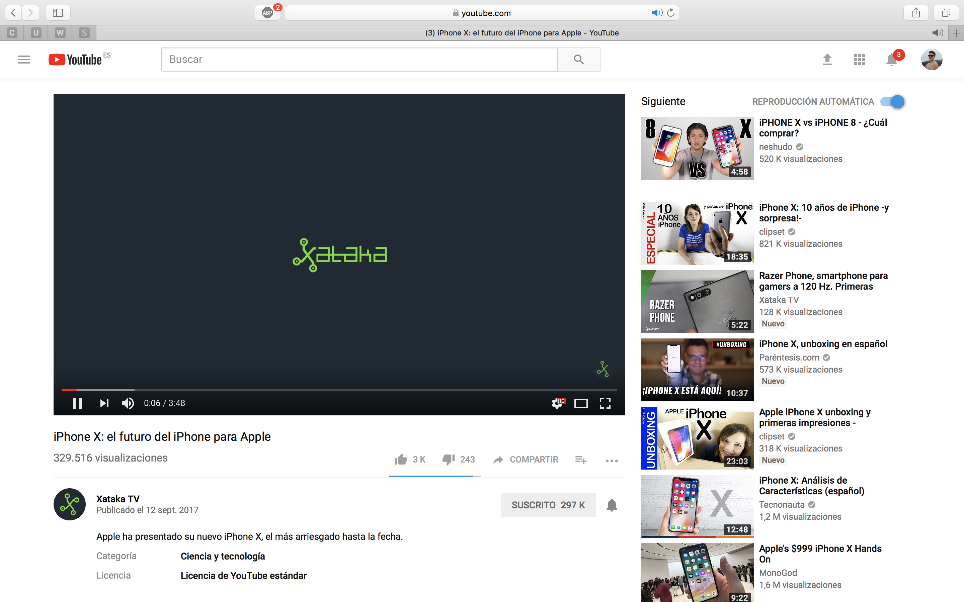The system should always keep informed the users about its performance, the tasks it is working on, in a reasonable time.

Here, we can see a bar inside the video player, which shows the photogram of the video we are placed in and the quantity of the total video which has been charged.

1. Match Between System and Real World

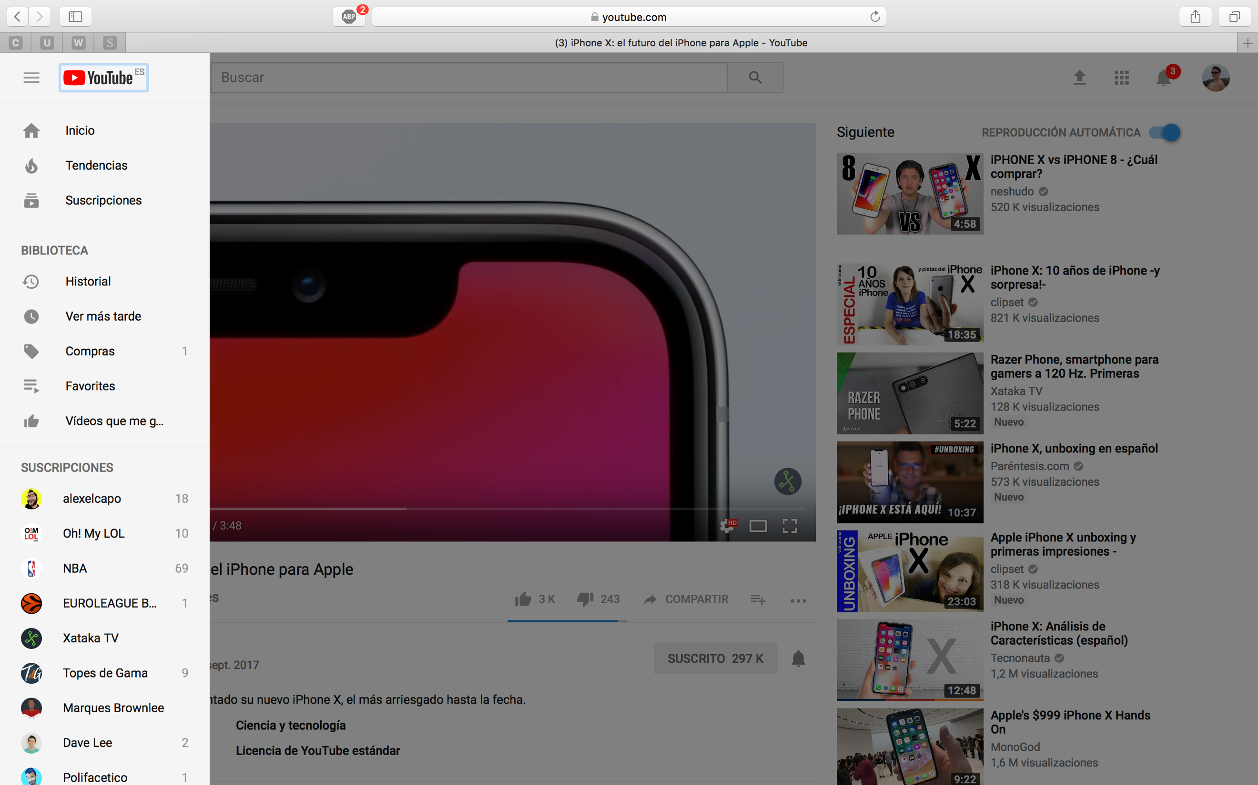The system should speak in the same language the user does. Real world conventions must be followed, making information appear in a natural and logical order.

Here, we can see the different categories in the menu, appearing first the most used and important options, and sequentially, more specific options more related with the explicit user who is using Youtube, as bought videos or subscriptions.

1. User Control and Freedom

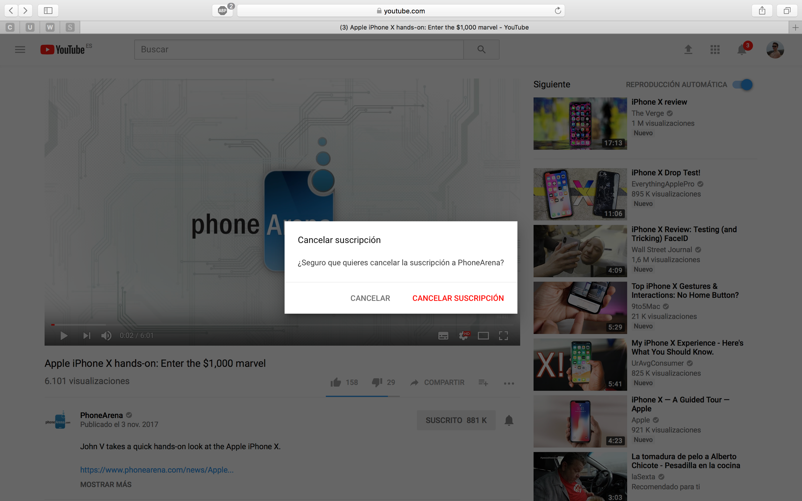Users often choose functions by mistake and they need a clear exit, leaving the unwanted state without making any undesired change.

In Youtube, we can find that options related with subscriptions and purchases are always accompanied by a tuple accept/cancel, providing the user the option of avoiding the changes if the button was clicked by error.

1. Consistency and Standards

Users should not have to wonder with different words, situations or actions which mean the same. Platform conventions must be accorded and followed.

Here, we see that the format used to express visualizations, new content, likes, dislikes, trusted channels and subscribers is always the same, providing the user a clear experience and understanding of the site.

1. Error Prevention

Either eliminate error-prone conditions or check for them and present users with a confirmation option before they commit to the action.

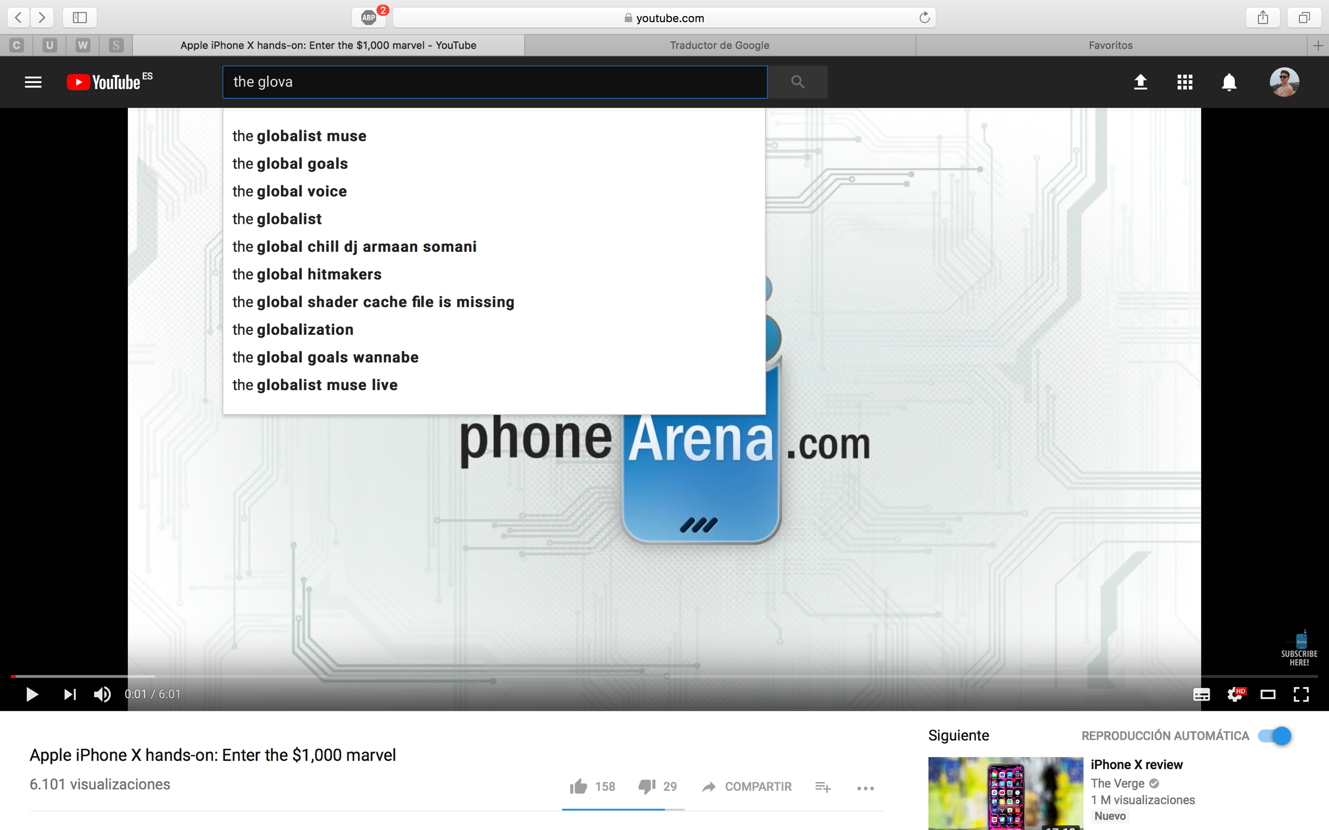

Youtube searcher provides a correction tool, returning the user the recommended results for the input he introduces. In this case, we are writing global with v, the searcher knows it and returns the results it considers are the most appropriated to the user’s input, but still gives the user the option of committing the input he has introduced in the search field.

1. Recognition Rather than Recall

Minimize the user’s memory load making the elements of the site visible.

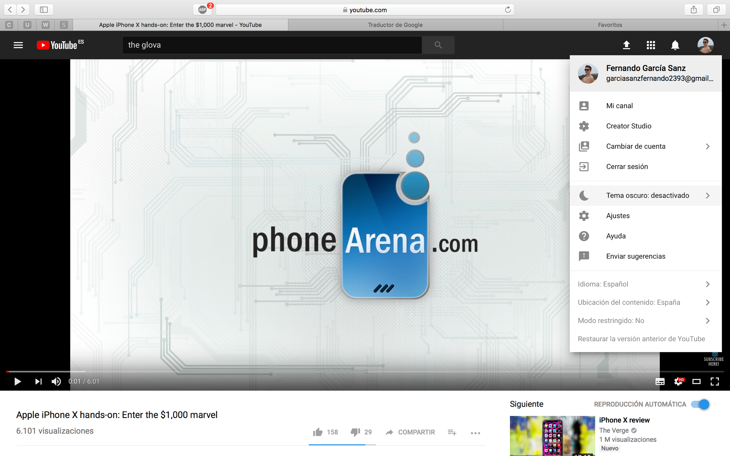

Here we can see that when an option is selected, the colour changes respect to the remaining ones, and also the selected option is expressed in each panel.

1. Flexibility and Efficiency of Use

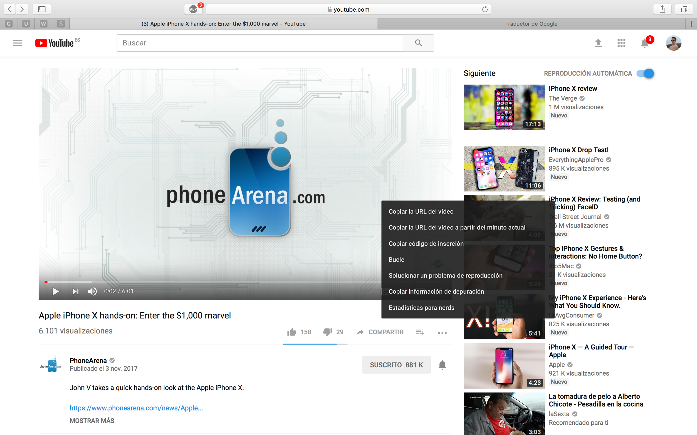The system should cater to both inexperienced and experienced users.

Youtube allows users to check the statistics of a video, play it in loop mode, copy URLs in different ways, solve playing problems and copy debugging information. Most of these options will be useless for the common client of the platform, but the most experienced users or some specific ones would maybe benefit from them.

1. Aesthetic and Minimalistic Design

Dialogues should not contain information which is irrelevant or rarely needed.

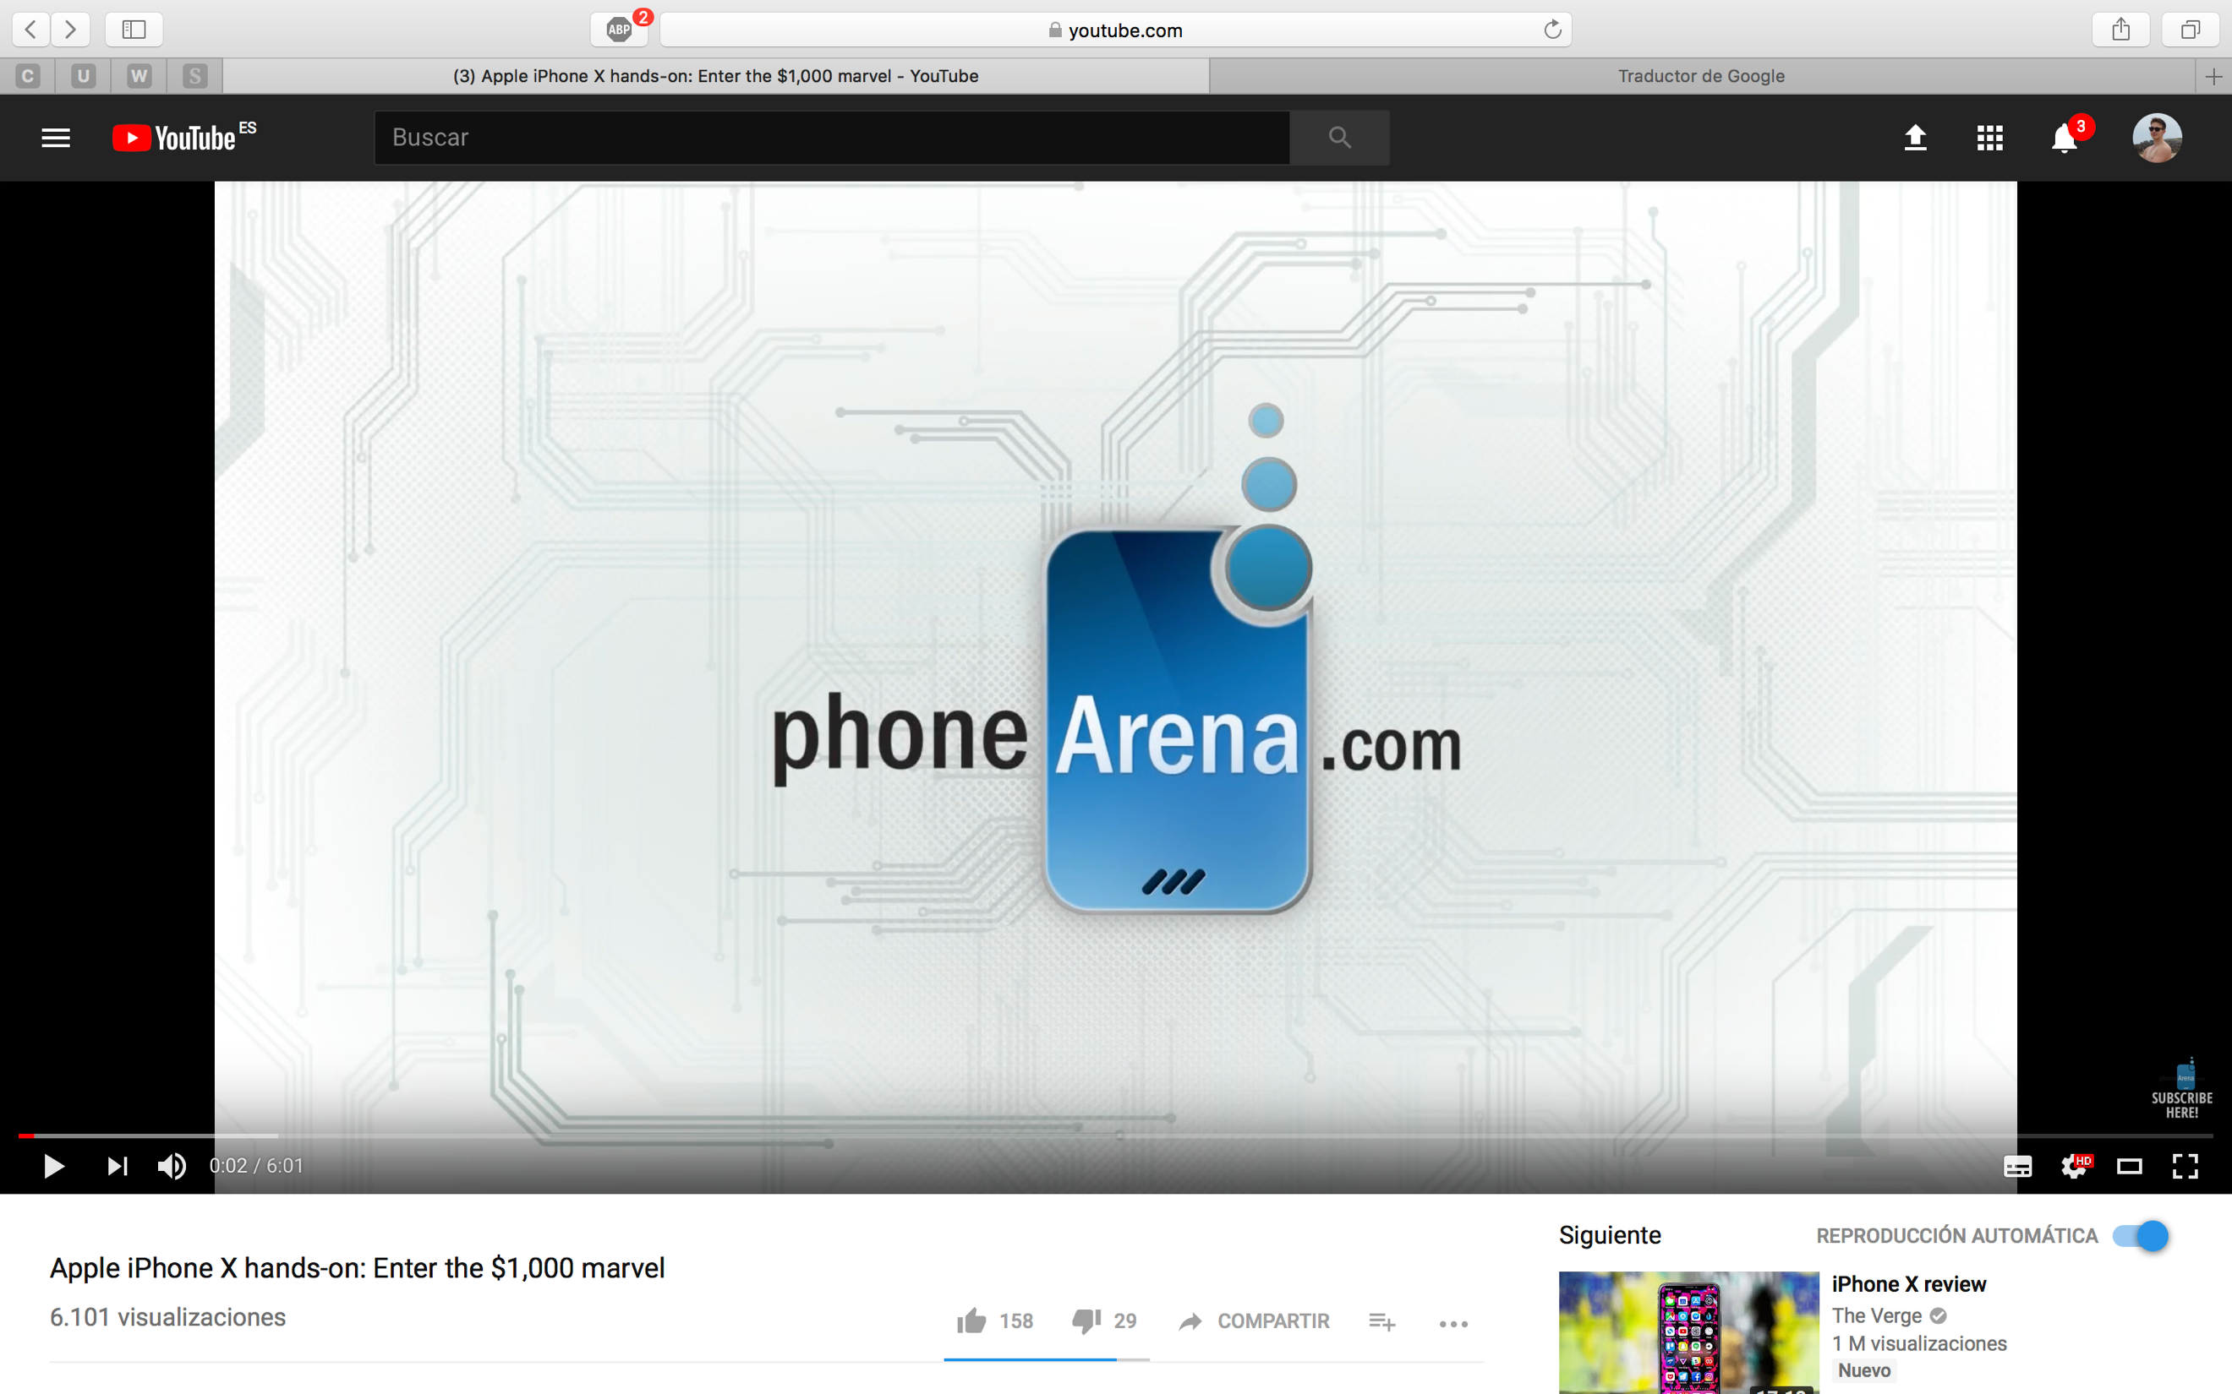

Youtube has an option which is called cinema mode, changing the format of the player and reducing even more any element which could provoke a distraction or a loose of space for the video, despite full screen mode is not activated.

1. Help Users Recognize, Diagnose and Recover from Errors

Error messages should be expressed in plain language, precisely indicate the problem and constructively suggest a solution.

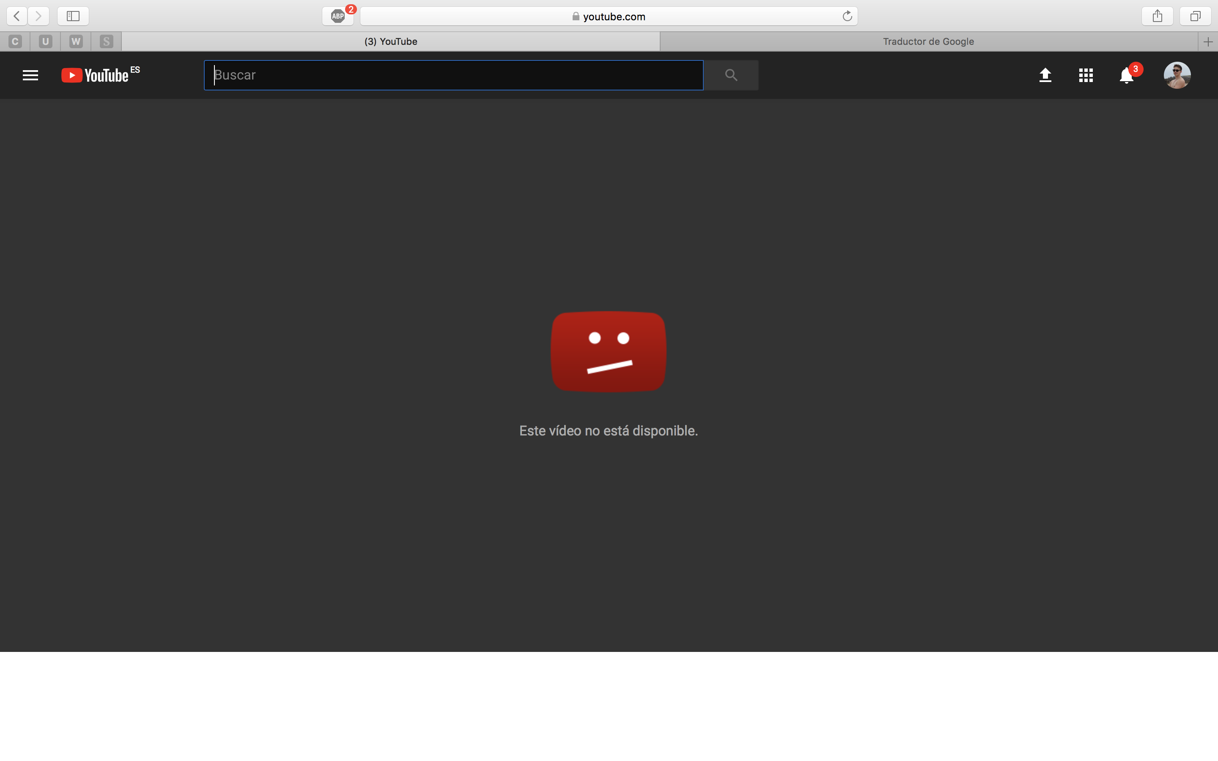

In Youtube, the main error is look for a video which is not available, because the channel has erased it or just because the video simply never existed and the URL is wrong. Youtube informs about it, but it is true that a solution is not given.

1. Help and Documentation

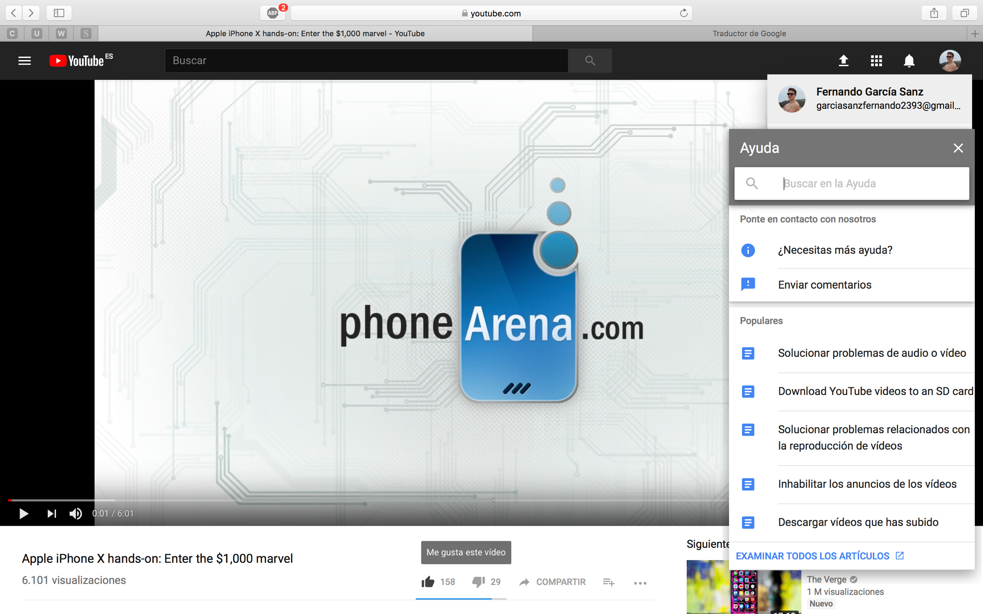Help information should be easy to search, focused on user’s task, list concrete steps to be carried out and not be too large.

Youtube platform offers a help men u in which you can select any option of the ones displayed or look for the one which better adapts to your needs.

## Van Duyne Patterns’ Analysis:

Van Duyne Patterns explain the rules to follow to achieve a good website design. There are several rules to follow, and we can find the next one in this platform:

Page Templates:

A webpage must be consistent with its design. We can notice that Youtube is a good example of it, because for each of its billions of videos, the format of the webpage does not change.

E-mail subscriptions:

A company needs a way to keep contact with its users and maintain them informed. Thanks to Google accounts, for Youtube is quite easy the fact of contact the clients of the platform.

About Us:

For a company, it is important to explain which goal it is dedicated to. In Youtube, we are able to find information about the site, the creators, advertisement, developers…

Privacy Preferences:

Clients of a website need an easy way to access and change the privacy settings. In Youtube, inside the personal account sections, we can find one call privacy, which allows to manage this kind of settings.

Sign In / New Account:

A single process has to handle both returning customers and new customers. The lower the quantity of information about the client is stored, the easier creating new accounts become. Google, so Youtube, has an easy and intuitive process to change and create accounts.

Guest Account:

It happens that many clients may refuse to use a site if they have to create or spend time creating an account. The option of using a website as a guest is recommended to avoid this problem. Youtube allows to use all functionalities which are no related which recommendations and subscriptions to the user to anyone who access the site without logging in.

Account Management:

Customers usually need to manage the information a webpage stores about them. Youtube allows the user to quickly access to his personal information and modify it if the client requests to do so.

Direct Manipulation:

Site customization, changing views, layouts… All these tasks may result difficult for the user. Youtube lets the user to change the webpage design theme, store videos to watch them later, stored the favourite content, etc.

Clear Forms:

Sometimes, when the user has to introduce data in a site, it could be frustrating, due to the format, the quantity of data required… Providing short and well-built formularies is a good idea to avoid it. Youtube requires few information, and thanks to Google accounts, these data can be easily modified and updated.

Predictive Input:

Filling forms and fields may become a tedious task. Google autocomplete functionality and the predictive searcher of Youtube are a great solution to avoid this kind of frustration.

Above the fold:

Customers sometimes loss information if they have to scroll down to visualize it completely. It is ideal to show all the important information at the top of the page. Youtube shows the most popular content and the new one first, giving you more possibilities about visualizing it.

Search Action Module:

Users usually want to swiftly jump from one point of the site to other. The searcher is in charge of this task. Youtube searcher allows to group up the content of the site according to diverse classifications: content, channels, words, date…

Organized Search Results:

Sometimes it is difficult for visitors to understand the content coming from a search. Youtube displays the content according to the affinity with the user search, making easier to understand the content.

Action Buttons:

It is a good idea for making a website intuitive to user buttons to represent actions. Youtube provides different visible buttons to perform the main actions, like subscribing to a channel, uploading content or change the section the user is located on.

Familiar Language:

Unfamiliar terms may provoke navigating in a website becomes a difficult job. Using common language which most users understand may attract more visitors and make easier for them to empathize with the site. Youtube presents a colloquial language, with no technicalities or strange words which may become navigation into a hell.